Exercise 1: Control Structures

Sample tables :

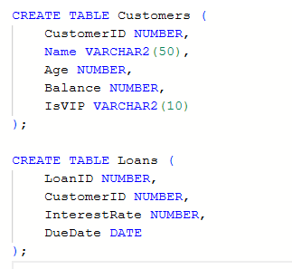

Sample data:

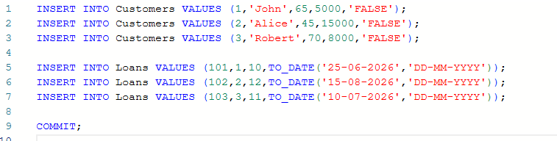

Scenario 1: The bank wants to apply a discount to loan interest rates for customers above 60 years old.
Query:

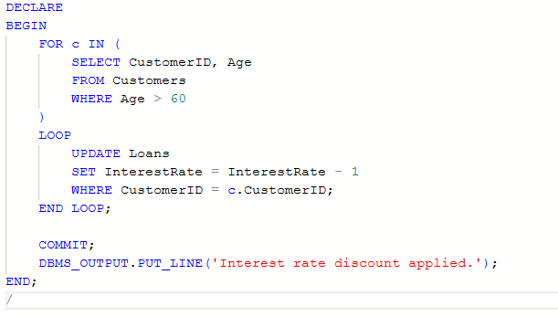
Script output:
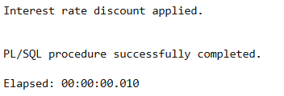

Explanation :
Loops through customers above 60 years and reduces their loan interest rate by 1%.

Scenario 2: A customer can be promoted to VIP status based on their balance.
Question: Write a PL/SQL block that iterates through all customers and sets a flag IsVIP to TRUE for those with a balance over $10,000.
Script/ Query :
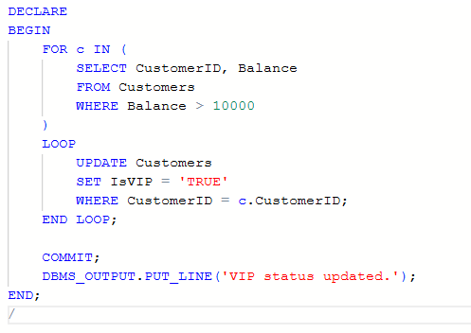
Script output:
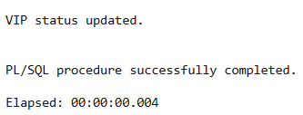

Explanation :
Marks customers as VIP when their account balance exceeds $10,000.

Scenario 3: The bank wants to send reminders to customers whose loans are due within the next 30 days.
Question: Write a PL/SQL block that fetches all loans due in the next 30 days and prints a reminder message for each customer.
Script/ Query:
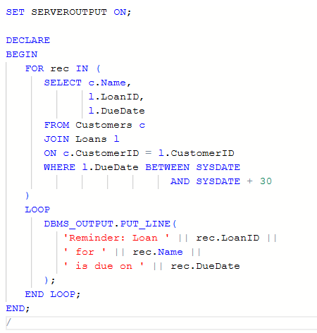
Script output:
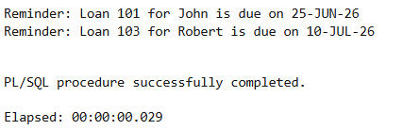

Explanation :
Fetches loans due within the next 30 days and prints reminder messages for customers.

